1. Write a program that takes a student's score as input and outputs the corresponding grade based on the following scale:

A: 90-100

B: 80-89

C: 70-79

D: 60-69

F: 0-59

CODE: -

package StudentScore;

import java.util.Scanner;

public class SC {

public static void main(String[] args) {

Scanner scanner = new Scanner(System.***in***); //create a scanner object to read input

System.***out***.print("Enter the student's score (0-100): "); //user to enter the student's score

int score = scanner.nextInt();

//grade based on the score

char grade;

if (score >= 90 && score <= 100) {

grade = 'A';

} else if (score >= 80 && score <= 89) {

grade = 'B';

} else if (score >= 70 && score <= 79) {

grade = 'C';

} else if (score >= 60 && score <= 69) {

grade = 'D';

} else if (score >= 0 && score <= 59) {

grade = 'F';

} else {

System.***out***.println("Invalid score. Please enter a score between 0 and 100."); //display an error message

scanner.close();

return;

}

System.***out***.println("The grade for the score " + score + " is: " + grade); //print the grade

scanner.close();

}

}

OUTPUT: -

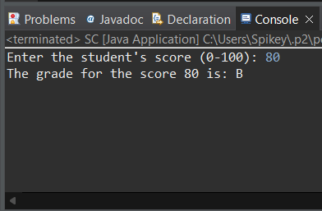

1. Write a program to check if a given year is a leap year. (A year is a leap year if it is divisible by 4 but not by 100, or it is divisible by 400.)

CODE: -

package LeapYear;

import java.util.Scanner;

public class LY {

public static void main(String[] args) {

Scanner scanner = new Scanner(System.***in***); //create a scanner object to read input

System.***out***.print("Enter a year: "); //user to enter a year

int year = scanner.nextInt();

boolean isLeapYear = false; //check if year is leap year

if (year % 4 == 0) {

if (year % 100 != 0 || year % 400 == 0) {

isLeapYear = true;

}

}

if (isLeapYear) {

System.***out***.println(year + " is a leap year.");

} else {

System.***out***.println(year + " is not a leap year.");

}

scanner.close();

}

}

OUTPUT: -

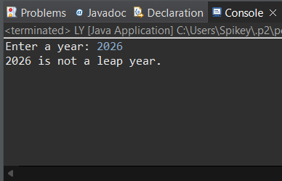

1. Write a program that takes an integer as input and checks if it is positive, negative, or zero.

CODE: -

package PositiveNegativeZero;

import java.util.Scanner;

public class PNZ {

public static void main(String[] args) {

Scanner scanner = new Scanner(System.***in***); //create a scanner object to read input

System.***out***.print("Enter an number: "); //user to enter an integer

int number = scanner.nextInt();

//check if the number is positive, negative, or zero

if (number > 0) {

System.***out***.println("The number " + number + " is positive.");

} else if (number < 0) {

System.***out***.println("The number " + number + " is negative.");

} else {

System.***out***.println("The number is zero.");

}

scanner.close();

}

}

OUTPUT: -

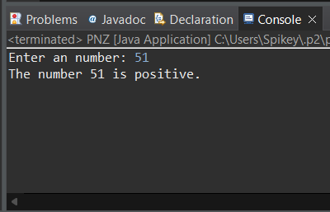

1. Write a program that prints numbers from 1 to 10 using a loop

CODE: -

package PrintNumbers1To10;

public class PrintNumbers {

public static void main(String[] args) {

//for loop to print numbers from 1 to 10

for (int i = 1; i <= 10; i++) {

System.***out***.println(i);

}

}

}

OUTPUT: -

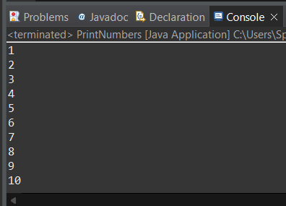

1. Write a program that takes an integer N as input and calculates the sum of entered numbers.

CODE: -

package CalculatesTheSum;

import java.util.Scanner;

public class CTS {

public static void main(String[] args) {

Scanner scanner = new Scanner(System.***in***); //create a scanner object to read input

System.***out***.print("Enter the integers to sum: "); //user to enter the number of integers

int N = scanner.nextInt();

int sum = 0; //a variable to store the sum

//to read N integers and calculate the sum

for (int i = 1; i <= N; i++) {

System.***out***.print("Enter number " + i + ": ");

int number = scanner.nextInt();

sum += number;

}

System.***out***.println("The sum of the entered numbers is: " + sum);

scanner.close();

}

}

OUTPUT: -

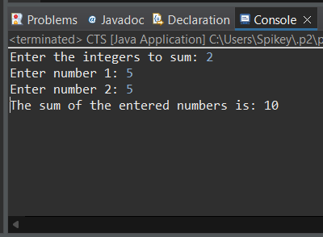

1. Write a program that takes an integer as input and prints its multiplication table up to 10.

CODE: -

package MultiplicationTable;

import java.util.Scanner;

public class MT {

public static void main(String[] args) {

Scanner scanner = new Scanner(System.***in***); //create a scanner object to read input

System.***out***.print("Enter an number: "); //user to enter an integer

int number = scanner.nextInt();

//print the multiplication table up to 10

System.***out***.println("Multiplication table of " + number + ":");

for (int i = 1; i <= 10; i++) {

System.***out***.println(number + " x " + i + " = " + (number * i));

}

scanner.close();

}

}

OUTPUT: -

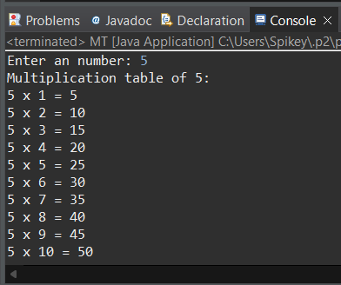

1. Write a program that takes a positive integer as input and prints its digits in reverse order.

CODE: -

package ReverseOrder;

import java.util.Scanner;

public class RO {

public static void main(String[] args) {

Scanner scanner = new Scanner(System.***in***); //create a scanner object to read input

//user to enter a positive integer

System.***out***.print("Enter a positive integer: ");

int number = scanner.nextInt();

//check if the input is a positive integer

if (number < 0) {

System.***out***.println("Please enter a positive integer.");

} else {

System.***out***.print("Digits in reverse order: "); //print the digits in reverse order

while (number > 0) {

int digit = number % 10;

System.***out***.print(digit);

number /= 10;

}

System.***out***.println();

}

scanner.close();

}

}

OUTPUT: -

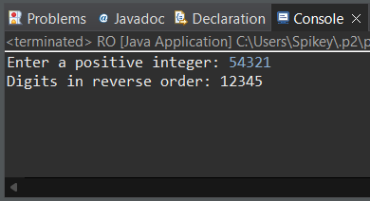

1. Create a class Animal with a method makeSound() that prints "Some generic animal sound". Create another class Dog that extends Animal and overrides the makeSound() method to print "Bark". Write a main method to demonstrate calling the makeSound() method on an Animal reference holding a Dog object.

CODE: -

package Ani;

class Animal {  //define the Animal class

    public void makeSound() {

        System.out.println("Some generic animal sound");

    }

}

class Dog extends Animal { //define the Dog class that extends Animal

    @Override

    public void makeSound() {

        System.out.println("Bark");

    }

}

public class Main { // Main class

    public static void main(String[] args) {

        Animal myDog = new Dog(); //create an Animal reference holding a Dog object

        myDog.makeSound();  //this will print "Bark"

    }

}

OUTPUT: -

